|| Session 2 – HTML & XHATML ||

# w3school website:-

Intro:

HTML is the standard markup language for Web pages.

With HTML you can create your own Website.

describes the structure of a Web page

Syntax:

* <!DOCTYPE html> 🡪 The <!DOCTYPE html> declaration defines that this document is an HTML5 document  
  <html> 🡪the root element  
  <head>🡪contain meta info  
  <title>Page Title</title>  
  </head>  
  <body>  
    
  <h1>This is a Heading</h1>  
  <p>This is a paragraph.</p>  
    
  </body>  
  </html>

# BASIC

HTML headings are defined with the <h1> to <h6> tags.

HTML paragraphs are defined with the <p> tag:

HTML links are defined with the <a> tag:

<a href="https://www.w3schools.com">This is a link</a>

HTML images are defined with the <img> tag.

<img src="w3schools.jpg" alt="W3Schools.com" width="104" height="142">

The <br> tag defines a line break, and is an empty element without a closing tag:

HTML is Not Case Sensitive

style attribute is used to add styles to an element,

<p style="color:red;">This is a red paragraph.</p>

The <hr> element is used to separate content (or define a change) in an HTML page:

Givr a horizontal line after P or H

The text inside a <pre> element is displayed in a fixed-width font (usually Courier), and it preserves both spaces and line breaks:

Use for poem when space pre space is needed.

#STYLE :

<body style="background-color:powderblue;">

<h1 style="color:blue;">This is a heading</h1>

<h1 style="font-family:verdana;">This is a heading</h1>

<h1 style="font-size:300%;">This is a heading</h1>

<h1 style="text-align:center;">Centered Heading</h1>

#TEXT FORMATTING :

<b> - Bold text

<strong> - Important text

<i> - Italic text

<em> - Emphasized text

<mark> - Marked text

<small> - Smaller text

<del> - Deleted text

<ins> - Inserted text

<sub> - Subscript text

<sup> - Superscript

The HTML <q> tag defines a short quotation.

Use the global title attribute to show the description for the abbreviation/acronym when you mouse over the element.

<abbr title="World Health Organization">WHO</abbr>

#COMMENTS:

<!-- <p>This is another paragraph </p> -->

<!—

<p>Lookatthiscoolimage:</p>  
<p>Thisisaparagraphtoo.</p>  
-->

#CSS

CSS stands for Cascading Style Sheets.

**Inline** - by using the style attribute inside HTML elements

**Internal** - by using a <style> element in the <head> section

**External** - by using a <link> element to link to an external CSS file

**The external style sheet can be written in any text editor. The file must not contain any HTML code, and must be saved with a .css extension.**

p {  
  border: 2px solid powderblue;  
}

padding: 30px;

 margin: 50px;

<link rel="stylesheet" href="https://www.w3schools.com/html/styles.css">

By default, links will appear as follows in all browsers:

* An unvisited link is underlined and blue
* A visited link is underlined and purple
* An active link is underlined and red

The target attribute can have one of the following values:

* + _self - Default. Opens the document in the same window/tab as it was clicked
  + _blank - Opens the document in a new window or tab
  + _parent - Opens the document in the parent frame
  + _top - Opens the document in the full body of the window

Use mailto: inside the href attribute to create a link that opens the user's email program (to let them send a new email):

#TABLE

#<table style="width:100%">

<caption>Monthlysavings</caption>  
  <tr>  
    <th>Firstname</th>  
  </tr>  
  <tr>  
    <td>Smith</td>  
  </tr>  
 </table>

#table,th,td {  
  border: 1pxsolidblack;  
 border-collapse: collapse;  
}

#<tr>  
    <th colspan="2">Name</th>  
    <th>Age</th>  
  </tr>

# <tr>  
    <th rowspan="2">Phone</th>  
    <td>555-1234</td>  
  </tr>

#<colgroup>  
    <col span="2" style="background-color:#D6EEEE">  
   <col span="3" style="background-color:pink">  
  </colgroup>

#List

Unordered

Ordered

#BLOCK

A block-level element always starts on a new line, and the browsers automatically add some space (a margin) before and after the element.

Two commonly used block elements are: <p> and <div>.

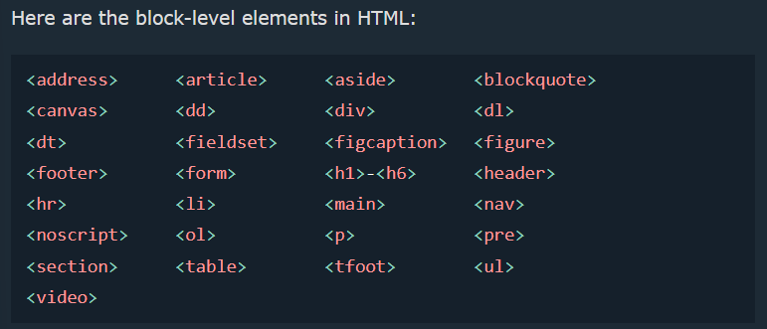

An inline element does not start on a new line.

#CLASS

To create a class; write a period (.) character, followed by a class name. Then, define the CSS properties within curly braces {}:

.city {  
  background-color: tomato;

}

#IFRAME

An HTML iframe is used to display a web page within a web page.

An inline frame is used to embed another document within the current HTML document.

<iframe src="*url*" title="*description*"></iframe>

**Tip:** It is a good practice to always include a title attribute for the <iframe>. This is used by screen readers to read out what the content of the iframe is.

#JAVASCRIPT

The HTML <script> tag is used to define a client-side script (JavaScript)

#FORM

<form>

**label**

 <label for="fname">Firstname:</label><br>

**input**  
  <input type="text" id="fname" name="fname"><br>

Radio Buttons

<input type="radio" id="html" name="fav_language" value="HTML">  
  <label for="html">HTML</label><br>

**Checkboxes**

<input type="checkbox" id="vehicle1" name="vehicle1" value="Bike">  
  <label for="vehicle1"> I have a bike</label><br>

**Submit Button**

<input type="submit" value="Submit">

**Date-time**

<label for="birthdaytime">Birthday(date and time):</label>  
   <input type="datetime-local" id="birthdaytime" name="birthdaytime">

**XHTML**

**Xhtml tutorials**

* XHTML is a short form of eXtensible HyperText Markup Language. It is a stricter form of HTML.

**What is xhtml:**

* cross between HTML and XML language.
* The above HTML code doesn't follow the HTML rule although it runs. Now a day, there are different browser technologies. Some browsers run on computers, and some browsers run on mobile phones or other small devices. The main issue with the bad HTML is that it can't be interpreted by smaller devices.
* So, XHTML is introduced to combine the strengths of HTML and XML.
* XHTML doesn't facilitate you to make badly formed code to be XHTML compatible. Unlike with HTML (where simple errors (like missing out a closing tag) are ignored by the browser), XHTML code must be exactly how it is specified to be.

**Html vs xhtml:**

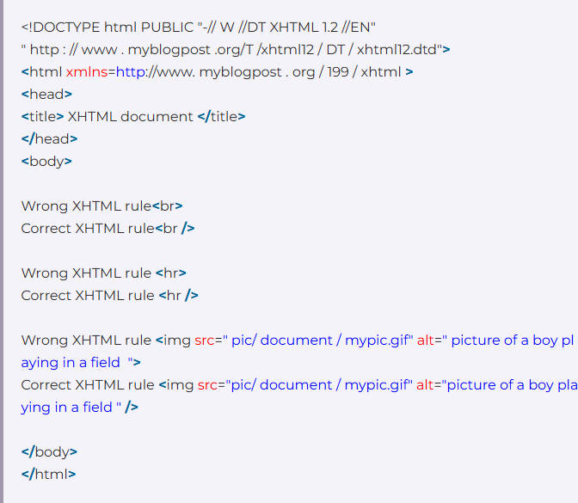

**Xhtml syntax :**

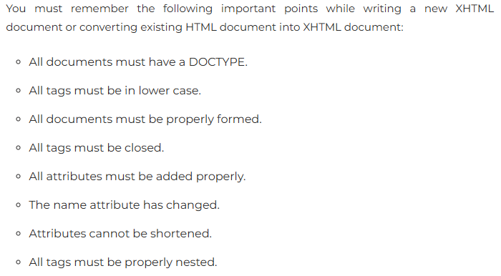

* XHTML is case-sensitive markup language. So, all the XHTML tags and attributes must be written in lower case.
* Href -> href
* An XHTML must have an equivalent closing tag. Even empty elements should also have closing tags. Let's see an example:
* <p> 🡪 <p> </p>
* All the XHTML attribute's values must be quoted. Otherwise, your XHTML document is assumed as an invalid document.
* Src = .. width =… -> src = “ ..” , width= “..”
* XHTML doesn't allow you to minimize attributes. You have to explicitly state the attribute and its value.

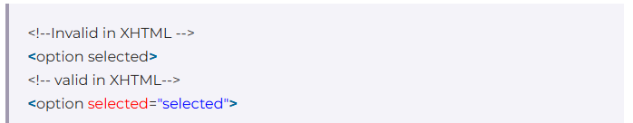

The id attribute is used to replace the name attribute. Instead of using name = "name", XHTML prefers to use id = "id".

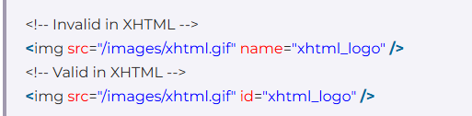

Nested proper

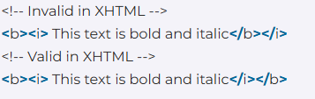

**Xhtml Events:**

* When you visit a website, you do things like click on text, images and hyperlinks, hover-over things, etc. These are examples of what JavaScript calls events.’
* **BODY AND FRAMESET:**

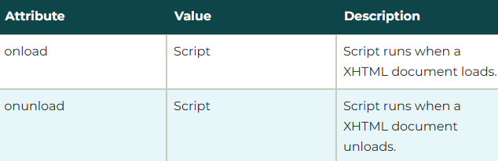

* **FORM:**
* 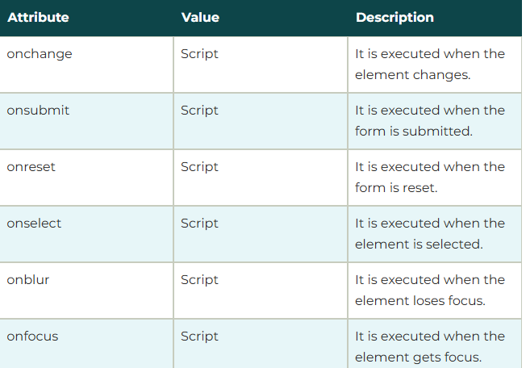
* **KEYBOARD EVENT:**
* 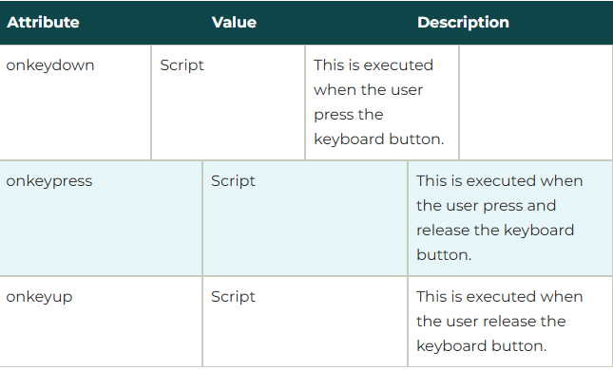
* **MOUSE EVENT:**
* 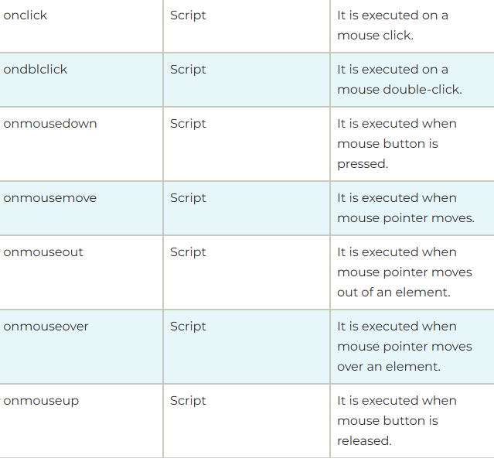

**XHTML DOCTYPE:**

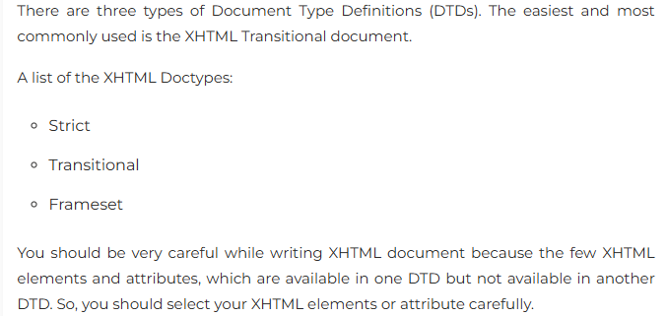

**XHTML ATTRIBUTES:**

